<https://angular-ui.github.io/bootstrap/#/datepicker>

bower install angular-bootstrap#0.13.4 --save

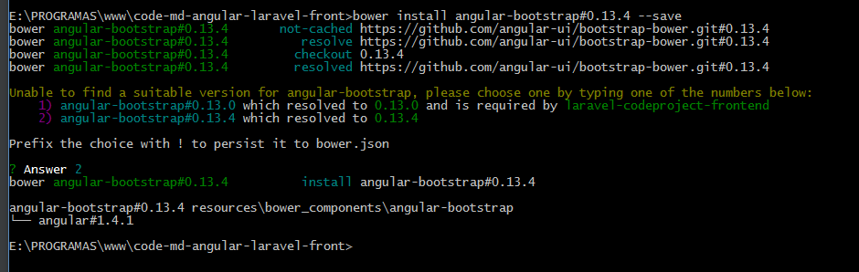

No app.js

Declarando a dependência

**var** app = angular.module('app', ['ngRoute', 'angular-oauth2', 'app.controllers', 'app.services',  
 'app.filters', 'app.directives','ui.bootstrap.typeahead', 'ui.bootstrap.datepicker', 'ui.bootstrap.tpls']);

Form Project new.html

<div class="form-group" ng-class="{'has-error': !formProject.due_date.$valid && formProject.due_date.$touched}">  
 <label class="col-md-4 control-label">Due Date</label>  
 <div class="col-md-6">  
 <p class="input-group">  
 <input type="text" class="form-control" name="due_date"  
 datepicker-popup="dd/MM/yyyy"  
 ng-model="project.due_date"  
 is-open="due_date.status.opened"  
 close-text="Close"  
 required />  
 <span class="input-group-btn">  
 <button type="button" class="btn btn-default" ng-click="open($event)">  
 <i class="glyphicon glyphicon-calendar"></i>  
 </button>  
 </span>  
 </p>  
  
  
 *<!--<input type="date" class="form-control" format-date name="due_date" ng-model="project.due_date" required>-->* <div ng-messages="formProject.due_date.$error" class="help-block" ng-show="formProject.due_date.$touched">  
 <div ng-message="required">Campo obrigatório!!</div>  
 </div>  
 </div>  
</div>

Adicionar no ProjectNew.js

$scope.due_date =  
{  
 status:  
 {opened: **false**}  
};  
$scope.open = **function** ($event) {  
 $scope.due_date.status.opened = **true**;  
};